

**Interfacing 8086**

**Made Simple**

***By Obed Mokweri***

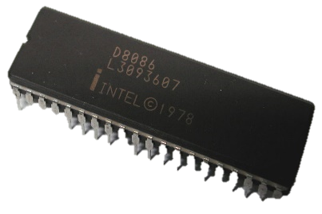**Contents;**

1. **8086 Pin Description**
2. **Interfacing**

**8086 Pin Description**

**8086 Pin Layout**

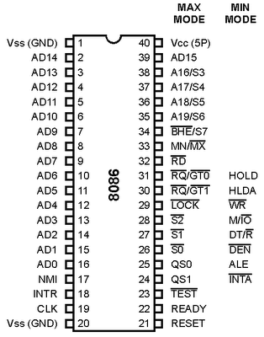

***Pin Diagram***

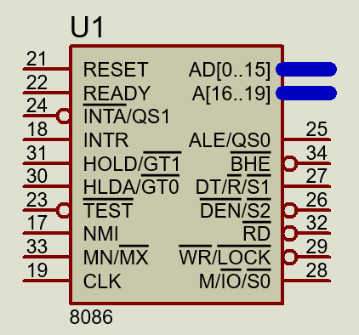

***8086 Layout in Proteus***

**Pin Description of 8086**

***AD0 - AD15 (I/O): Address Data Bus***

These lines constitute the time multiplexed memory/IO address during the first clock cycle (T1) and data during T2, T3 and T4 clock cycles. A0 is analogous to BHE for the lower byte of the data bus, pins D0-D7. A0 bit is Low during T1 state when a byte is to be transferred on the lower portion of the bus in memory or I/O operations. 8-bit oriented devices tied to the lower half would normally use A0 to condition chip select functions. These lines are active high and float to tri-state during interrupt acknowledge and local bus "Hold acknowledge".

***A19/S6, A18/S5, A17/S4, A16/S3 (0): Address/Status***

During T1 state these lines are the four most significant address lines for memory operations. During I/O operations these lines are low. During memory and I/O operations, status information is available on these lines during T2, T3, and T4 states. S5: The status of the interrupt enable flag bit is updated at the beginning of each cycle. The status of the flag is indicated through this bus.

***S6:***

When Low, it indicates that 8086 is in control of the bus. During a "Hold acknowledge" clock period, the 8086 tri-states the S6 pin and thus allows another bus master to take control of the status bus.

***S3 & S4:***

Lines are decoded as follows:

|  |  |  |
| --- | --- | --- |
| **A17/S4** | **A16/S3** | **Function** |
| 0 | 0 | Extra segment access |
| 0 | 1 | Stack segment access |
| 1 | 0 | Code segment access |
| 1 | 1 | Data segment access |

After the first clock cycle of an instruction execution, the A17/S4 and A16/S3 pins specify which segment register generates the segment portion of the 8086 address. Thus, by decoding these lines and using the decoder outputs as chip selects for memory chips, up to 4 Megabytes (one Mega per segment) of memory can be accesses. This feature also provides a degree of protection by preventing write operations to one segment from erroneously overlapping into another segment and destroying information in that segment.

***BHE /S7 (O): Bus High Enable/Status***

During T1 state the BHE should be used to enable data onto the most significant half of the data bus, pins D15 - D8. Eight-bit oriented devices tied to the upper half of the bus would normally use BHE to control chip select functions. BHE is Low during T1 state of read, write and interrupt acknowledge cycles when a byte is to be transferred on the high portion of the bus.   
The S7 status information is available during T2, T3 and T4 states. The signal is active Low and floats to 3-state during "hold" state. This pin is Low during T1 state for the first interrupt acknowledge cycle. 

***RD (O): READ***

The Read strobe indicates that the processor is performing a memory or I/O read cycle. This signal is active low during T2 and T3 states and the Tw states of any read cycle. This signal floats to tri-state in "hold acknowledge cycle".   
  
***TEST (I)***

TEST pin is examined by the "WAIT" instruction. If the TEST pin is Low, execution continues. Otherwise the processor waits in an "idle" state. This input is synchronized internally during each clock cycle on the leading edge of CLK. 

***INTR (I): Interrupt Request***

It is a level triggered input which is sampled during the last clock cycle of each instruction to determine if the processor should enter into an interrupt acknowledge operation. A subroutine is vectored to via an interrupt vector look up table located in system memory. It can be internally masked by software resetting the interrupt enable bit INTR is internally synchronized. This signal is active HIGH.

***NMI (I): Non-Maskable Interrupt***

An edge triggered input, causes a type-2 interrupt. A subroutine is vectored to via the interrupt vector look up table located in system memory. NMI is not maskable internally by software. A transition from a LOW to HIGH on this pin initiates the interrupt at the end of the current instruction. This input is internally synchronized.

***Reset (I)***

Reset causes the processor to immediately terminate its present activity. To be recognized, the signal must be active high for at least four clock cycles, except after power-on which requires a 50 Micro Sec. pulse. It causes the 8086 to initialize registers DS, SS, ES, IP and flags to all zeros. It also initializes CS to FFFF H. Upon removal of the RESET signal from the RESET pin, the 8086 will fetch its next instruction from the 20-bit physical address FFFF0H. The reset signal to 8086 can be generated by the 8284. (Clock generation chip). To guarantee reset from power-up, the reset input must remain below 1.5 volts for 50 Micro sec. after Vcc has reached the minimum supply voltage of 4.5V.

***Ready (I)***

Ready is the acknowledgement from the addressed memory or I/O device that it will complete the data transfer. The READY signal from memory or I/O is synchronized by the 8284-clock generator to form READY. This signal is active HIGH. The 8086 READY input is not synchronized. Correct operation is not guaranteed if the setup and hold times are not met.

***CLK (I): Clock***

Clock provides the basic timing for the processor and bus controller. It is asymmetric with 33% duty cycle to provide optimized internal timing. Minimum frequency of 2 MHz is required, since the design of 8086 processors incorporates dynamic cells. The maximum clock frequencies of the 8086-4, 8086 and 8086-2 are4MHz, 5MHz and 8MHz respectively.   
Since the 8086 does not have on-chip clock generation circuitry, and 8284 clock generator chip must be connected to the 8086 clock pin. The crystal connected to 8284 must have a frequency 3 times the 8086 internal frequency. The 8284 clock generation chip is used to generate READY, RESET and CLK.

***MN/MX (I): Maximum / Minimum***

This pin indicates what mode the processor is to operate in. In minimum mode, the 8086 itself generates all bus control signals. In maximum mode the three status signals are to be decoded to generate all the bus control signals.   
Minimum Mode Pins The following 8 pins function descriptions are for the 8086 in minimum mode; MN/ MX = 1. The corresponding 8 pins function descriptions for maximum mode is explained later.

***M/IO (O): Status line***

This pin is used to distinguish a memory access or an I/O accesses. When this pin is Low, it accesses I/O and when high it accesses memory. M / IO becomes valid in the T4 state preceding a bus cycle and remains valid until the final T4 of the cycle. M/IO floats to 3 - state OFF during local bus "hold acknowledge".

***WR (O): Write***

Indicates that the processor is performing a write memory or write IO cycle, depending on the state of the M /IO signal. WR is active for T2, T3 and Tw of any write cycle. It is active LOW, and floats to 3-state OFF during local bus "hold acknowledge ".

***INTA (O): Interrupt Acknowledge***

It is used as a read strobe for interrupt acknowledge cycles. It is active LOW during T2, T3, and T4 of each interrupt acknowledge cycle.

***ALE (O): Address Latch Enable***

ALE is provided by the processor to latch the address into the 8282/8283 address latch. It is an active high pulse during T1 of any bus cycle. ALE signal is never floated.

***DT/ R (O): DATA Transmit/Receive***

In minimum mode, 8286/8287 transceiver is used for the data bus. DT/ R is used to control the direction of data flow through the transceiver. This signal floats to tri-state off during local bus "hold acknowledge". 

***DEN (O): Data Enable***

It is provided as an output enable for the 8286/8287 in a minimum system which uses the transceiver. DEN is active LOW during each memory and IO access. It will be low beginning with T2 until the middle of T4, while for a write cycle, it is active from the beginning of T2 until the middle of T4. It floats to tri-state off during local bus "hold acknowledge".

***HOLD & HLDA (I/O): Hold and Hold Acknowledge***

Hold indicates that another master is requesting a local bus "HOLD". To be acknowledged, HOLD must be active HIGH. The processor receiving the "HOLD " request will issue HLDA (HIGH) as an acknowledgement in the middle of the T1-clock cycle. Simultaneous with the issue of HLDA, the processor will float the local bus and control lines. After "HOLD" is detected as being Low, the processor will lower the HLDA and when the processor needs to run another cycle, it will again drive the local bus and control lines.   
Maximum Mode The following pins function descriptions are for the 8086/8088 systems in maximum mode (i.e.. MN/MX = 0). Only the pins which are unique to maximum mode are described below.

***S2, S1, S0 (O): Status Pins***

These pins are active during T4, T1 and T2 states and is returned to passive state (1,1,1 during T3 or Tw (when ready is inactive). These are used by the 8288 bus controller to generate all memory and I/O operation) access control signals. Any change by S2, S1, S0 during T4 is used to indicate the beginning of a bus cycle. These status lines are encoded as shown in table 3.

|  |  |  |  |
| --- | --- | --- | --- |
| **S2** | **S1** | **S0** | **Characteristics** |
| 0 | 0 | 0 | Interrupt acknowledge |
| 0 | 0 | 1 | Read I/O port |
| 0 | 1 | 0 | Write I/O port |
| 0 | 1 | 1 | Halt |
| 1 | 0 | 0 | Code access1 0 1 Read memory |
| 1 | 1 | 0 | Write memory |
| 1 | 1 | 1 | Passive State |

***QS0, QS1 (O): Queue – Status***

Queue Status is valid during the clock cycle after which the queue operation is performed. QS0, QS1 provide status to allow external tracking of the internal 8086 instruction queue. The condition of queue status is shown in table below.  
  
Queue status allows external devices like In-circuit Emulators or special instruction set extension co-processors to track the CPU instruction execution. Since instructions are executed from the 8086 internal queue, the queue status is presented each CPU clock cycle and is not related to the bus cycle activity. This mechanism allows (1) A processor to detect execution of a ESCAPE instruction which directs the co- processor to perform a specific task and (2) An in-circuit Emulator to trap execution of a specific memory location.

|  |  |  |
| --- | --- | --- |
| **QS1** | **QS1** | **Characteristics** |
| 0 | 0 | No operation |
| 0 | 1 | First byte of opcode from queue |
| 1 | 0 | Empty the queue |
| 1 | 1 | Subsequent byte from queue |

***LOCK (O)***

It indicates to another system bus master, not to gain control of the system bus while LOCK is active Low. The LOCK signal is activated by the "LOCK" prefix instruction and remains active until the completion of the instruction. This signal is active Low and floats to tri-state OFF during 'hold acknowledge'.

Example:

LOCK XCHG reg., Memory ; Register is any register and memory GT0

; is the address of the semaphore.

***RQ/GT0 and RQ/GT1 (I/O): Request/Grant***

These pins are used by other processors in a multi-processor organization. Local bus masters of other processors force the processor to release the local bus at the end of the processors current bus cycle. Each pin is bi-directional and has an internal pull up resistors. Hence, they may be left un-connected.

**Interfacing**

In this section, I will show how to interface Intel 8086 microprocessor with interface chips (for this case 8255) using Proteus Professional ISIS schematic editor.

The AD0 to AD15 are address and data time multiplexed and so they must be demultiplexed to latch the address line A0 to A15. For these lines we need a 74LS373. The A16 to A19 are also multiplexed so would also need to demultiplex these signals using another 74LS373, if we needed them. So, we need to a 74LS373 latch. How to connect the latch to the 8086 is shown in the figure below.

In other to increase the data (D0 to D15) signal strength so that they can reach farther distance across the PCB we can add transceiver buffer 74LS245. The 74LS245 takes in 8 inputs and buffers the signals and outputs those 8 input signals. So, we connect the data lines from the microprocessor to the transceiver as shown by the circuit schematic below. In that figure, the chip is a 744LS245 octal transceiver to which the AD0 to AD7 are connected to get data lines D0 to D7.

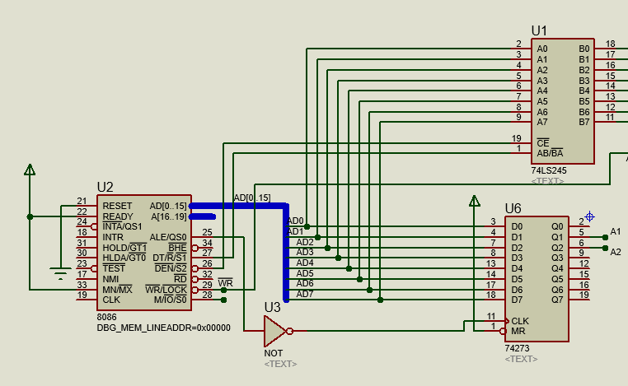

In the same figure we have connected the CE and the AB/BA pins of the 74LS245. These needs to be connected to the 8086 microprocessor data enable (DE) which has pin number 26 and the data direction controller pin(DT/R) which has pin number 27. These two pins of the microprocessor are shown below in closer look.

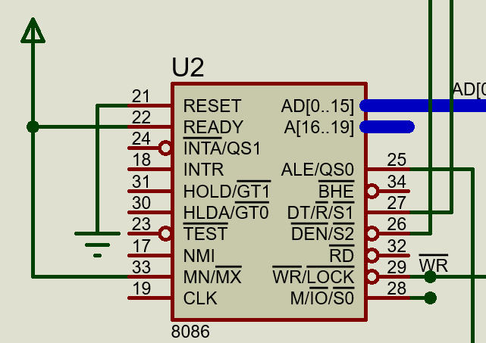

The data transfer controller signal from pin DT/R controls the data transfer to and from the microprocessor since the data bus is a bidirectional bus. DT means Data Transmit and R indicates Data Receive. This pin should be connected to the AB/BA. Another pin is the DEN which stands for Data Enable which is active low which should be connected to the CE (Chip Enable which is also active low) pin of the 74LS245 bus buffer. So, with this connection the new schematic showing demultiplexing and transceiver circuit for 8086 microprocessor as shown above.

**The PPI Interface.**

The latch in the connection is used to output the address from the microprocessor to the programmable peripheral interface.

The complete circuit diagram in Proteus is given below;

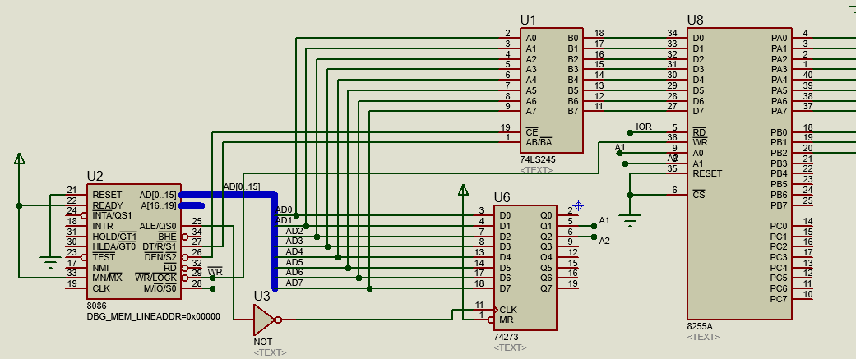

**8255 Pin Connections;**

1. ***Pins [Do…D7];*** These are the pins used for data transmission from the microprocessor to the selected ports or from the ports to the selected register in the microprocessor.
2. ***RD:*** Read signal controlled by the RD signal from the microprocessor.
3. ***WR:*** Write signal controlled by the WR signal from the microprocessor.
4. ***A0 and A1:*** These are the two addresses which determine which port is addressed by the microprocessor to be used for an input or output operation.
5. ***RESET:*** It is grounded to avoid resetting of the programmable peripheral interface (PPI).
6. ***CS:*** It is also grounded so as to select this chip.

When it comes to adressing the ports of 8255 the logic table below is used;

|  |  |  |  |
| --- | --- | --- | --- |
| A2 | A1 | A0 | Port selected |
| 0 | 0 | 0 | PORT A |
| 0 | 1 | 0 | PORT B |
| 1 | 0 | 0 | PORT C |
| 1 | 1 | 0 | Control register |

***References***;

<http://mrgsoftware.blogspot.co.ke/2015/05/step-by-step-tutorial-to-interface-8086.html>

<http://scanftree.com/microprocessor/Applications-of-Microprocessors>

<https://www.electronicshub.org/latches/>

*NOTE: This document and its accompanying files are also available for download in* [*Github*](http://www.github.com)*, a tool I recommend to you guys. The particular link will be provided.*

*Look forward to the next document release. I will always share any good stuff I manage to chew as long as God gives breathe. Should you find any challenges, I would be glad to help or we can Google it together. But always try finding a solution yourself first.*

[*mogsobd@gmail.com*](mailto:mogsobd@gmail.com)

*NEXT Release: 8255 Interface*

*HAVE FUN MEMBERS!!!!!*